2.

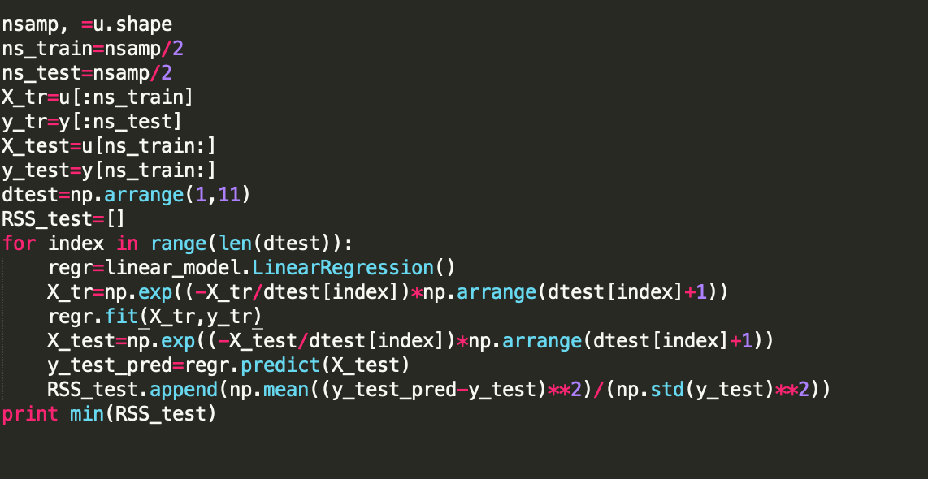

3.

(a) $E\left(\frac{\sum_{i=1}^{N}{y_{i}}}{\sum_{i=1}^{N}{x_{i}^{2}}} x_{}^{2}\right)-β_{0}x_{}^{2}= E\left(β_{0}x_{}^{2}\right)-β_{0}x_{}^{2}=0$

(b) $\frac{\sum_{i=1}^{N}{y_{i}}}{\sum_{i=1}^{N}{x_{i}^{2}}} x_{}^{2}-β_{0}x_{}^{2}=β_{0}x_{i}^{2}+E\left(\frac{{Nϵ}_{i}}{\sum_{i=1}^{N}{x_{i}^{2}}}\right)-{β_{0}x_{i}^{2}}_{}=0$

(c) $E\left( \frac{\sum_{i=1}^{N}{y_{i}}}{\sum_{i=1}^{N}{x_{i}^{2}}} x_{}^{2}\right)-β_{0}{\left(x_{}\right)}^{2}=β_{0}\frac{σ^{2}}{\sum_{i=1}^{N}{x_{i}^{2}}}x_{}^{2}$

4.

(a) $\hat{β}=\underset{}{\arg{\min_{β}{\sum_{i=1}^{n}{{\left(y_{i}-β_{0}-β_{1}x_{i}\right)}^{2}}}}}{}$

$$\frac{∂\hat{β}}{∂β_{0}}=-2\sum_{i=1}^{n}{{\left(y_{i}-β_{0}-β_{1}x_{i}\right)}^{}}$$

$$\frac{∂\hat{β}}{∂β_{1}}=-2\sum_{i=1}^{n}{{x_{i}\left(y_{i}-β_{0}-β_{1}x_{i}\right)}^{}}$$

Let $\frac{∂\hat{β}}{∂β_{0}}$ and $\frac{∂\hat{β}}{∂β_{1}}$ both equal to zero to calculate $β_{0}$ and $β_{1}$

(b) $\frac{∂\hat{β}}{∂β_{0}}=-2\sum_{i=1}^{n}{{\left(β_{00}+β_{01}x_{i}+β_{02}x_{i}^{2}-β_{0}-β_{1}x_{i}\right)}^{}}$

$$\frac{∂\hat{β}}{∂β_{1}}=-2\sum_{i=1}^{n}{{x_{i}\left(β_{00}+β_{01}x_{i}+β_{02}x_{i}^{2}-β_{0}-β_{1}x_{i}\right)}^{}}$$

In the same way to calculate $\hat{β}$, let $\frac{∂\hat{β}}{∂β_{0}}$ and $\frac{∂\hat{β}}{∂β_{1}}$ both equal to zero.

(c)(d)

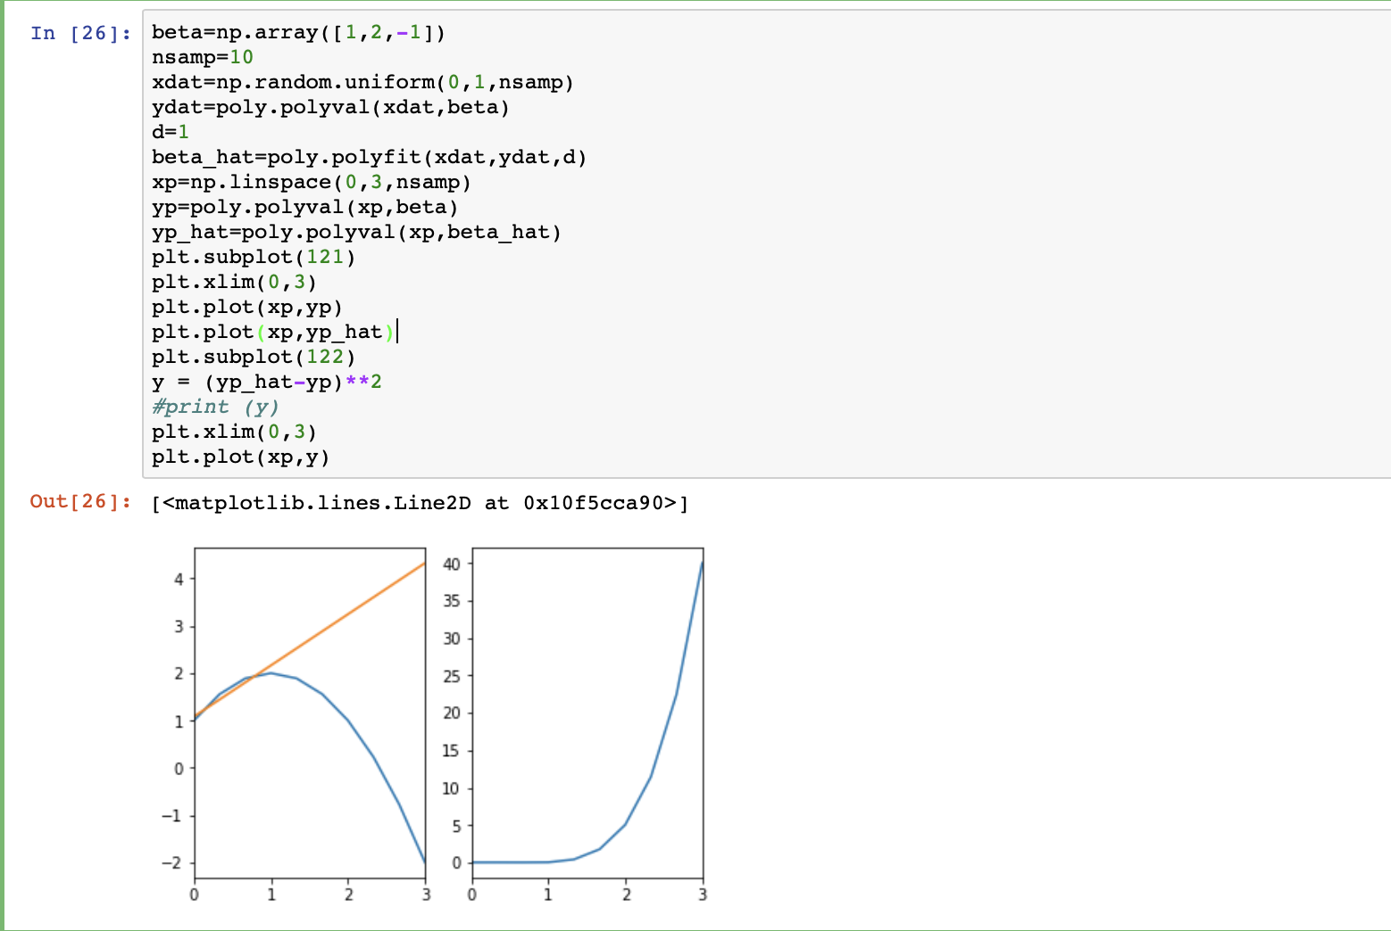

so when x=3, $Bi{as}^{2}(x)$ will be largest.

5.(a) $x_{0}$: cancer volume

$x_{1}:$ age

$x_{1}$: cancer type

Model 1: $y= β_{0}+β_{1}x_{0}$

Mode12: $y=β_{0}+β_{1}x_{0}+β_{1}x_{1}$

Model3: $y=β_{0}+ β_{1}ϕ_{0}x_{0}+β_{2}ϕ_{1}x_{0}+β_{3}x_{1}$, $ϕ_{0}$ and $ϕ_{1}$ are binary features

Type I: $y=β_{0}+ β_{1}x_{0}+β_{3}x_{1}$

Type II: $y=β_{0}+ β_{2}x_{0}+β_{3}x_{1}$

(b) Model 1 has two parameters

Model 2 has three parameters

Model 3 has three parameters

Model 3 is the most complex.

(c)Model 1: $A= \left(\begin{matrix}1 & 0.7 \\ 1 & 1.3 \\ 1 & 1.6\end{matrix}\right)$

Model 2: $A=\left(\begin{matrix}1 & 0.7 & 55 \\ 1 & 1.3 & 65 \\ 1 & 1.6 & 70\end{matrix}\right)$

Model 3: $A=\left(\begin{matrix}1 & 0.7 & \begin{matrix}0 & 55\end{matrix} \\ 1 & 0 & \begin{matrix}1.3 & 65\end{matrix} \\ 1 & 0 & \begin{matrix}1.6 & 70\end{matrix}\end{matrix}\right)$

(d)Rsq_tgt = 0.7 +0.05/ $\sqrt{10-1}$ =0.7171

Mode13’s Rss_mean is less than Rsq_tgt , so we can choose model 3.